**FOCUS - HOW TO ACCESS THE ASAM CONTINUUM ASSESSMENT**

1 – Open the ‘SUD/CA (NEW)’ main menu:

2 – Open the ‘ASAM Continuum’ sub-menu:

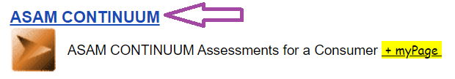

3 – Search by the Focus ID (if known – from previous admission) otherwise, search by Social Security Number for the consumer. If still not found, search by Medicaid ID (this can be done on the Home Screen by selecting “Medicaid Lookup”.

* Case Number
* SSN
* Medicaid ID

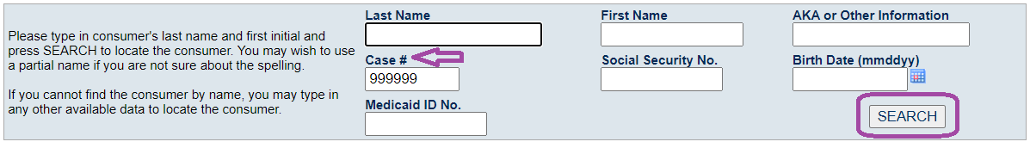

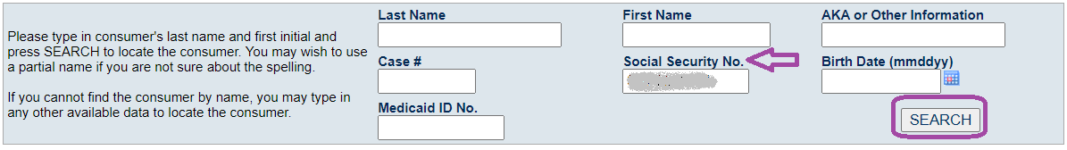

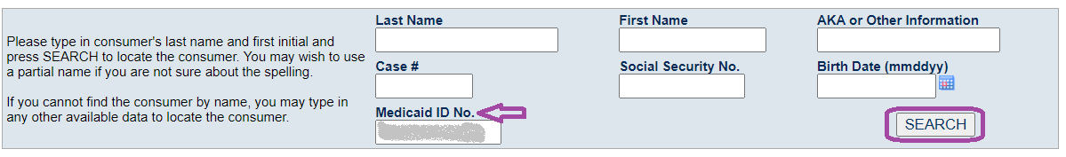

If you cannot find the consumer using **ALL** of the preceding steps, search by exact name and date of birth:

* First Name
* Last Name
* DOB

*Note: All three fields are required to search on and will display results for identical matches only (searching for Joseph Consumer will produce no results if the name is Joe Consumer)*

*Note: Due to changes made to the FOCUS system to allow providers to open the ASAM Continuum without Access center requests, increased protections have been put into place to ensure compliance with 42 CFR. Therefore, exact information is needed to search for consumers. If your first search does not produce a result, please try a different search prior to adding a consumer. In order to avoid multiple cases for the same person, all attempts should be made to locate the case in FOCUS prior to adding a new consumer.*

4a - If the consumer is found, click ‘Select’ to enter the ASAM for the selected consumer & proceed to step 5:



4b - If the consumer is NOT found, click ‘Add Consumer’. Enter the consumer’s basic demographic information (see highlighted areas). Upon saving, this will create a new consumer record in FOCUS:



*Note: Specific demographic information must be added in order to move to the next step. The system requires: First Name, Last Name, and Gender assigned at birth.*

5a – If the consumer already has a record in the ASAM Continuum System, click the ‘Add ASAM CONTIUUM Assessment’ link:



5b – If the consumer does NOT yet have a record in the ASAM Continuum System, click the ‘Create Consumer Record in ASAM CONTIUUM…’ link:



6a – Once the ASAM Continuum and other intake documents have been completed, submit the request to open case along with the release of information to the MCCMH Access Center in order to get a treatment referral opened.

6b-Once the treatment referral has been opened, add the Admission record, insurance policies and any authorization requests (as appropriate).

*Note:*

* *The consumer* ***does not*** *need to have a Treatment Referral or Release prior to adding an ASAM CONTINUUM. There is no need to enter an admission record for the consumer when adding an ASAM CONTINUUM.*
* *All other documentation/tasks in FOCUS* ***will require*** *the consumer have a Treatment Referral/Release and will follow the standard workflow.*