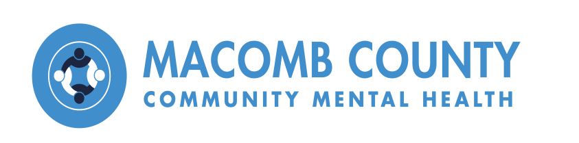

**Substance Use Disorder Health Home Program Enrollment Consent**

[www.mccmh.net](https://www.mccmh.net/substance-use-disorder/) | 855-99-MCCMH

Michigan Medicaid beneficiaries have access to health home services for substance use disorders. The program is available to individuals who have Medicaid, Healthy Michigan Plan, or MI Child, live in Macomb County, and have a diagnosed opioid use disorder. The Michigan Department of Health and Human Services (MDHHS) recognizes that living with a substance use disorder is hard; the Substance Use Disorder Health Home (SUDHH) Program is designed to help. You will be provided services as part of your Medicaid benefit that will help you take control of your health and work toward long-term recovery. By signing below you are agreeing to enroll in the SUDHH Program at Provider Name, to working with your Care Team here, and that you understand your Care Team will have access to MDHHS administrative claims data through the Waiver Support Application for the purposes of care coordination and continuity of care. You may also opt-out (disenroll) now, or at any time in the future, with no impact on your currently entitled Medicaid services.

**The Substance Use Disorder Health Home Program**…

* Is not a place, but is a model of care that offers care coordination services.
* Takes a holistic approach to your health care and provides you with one “home” base for coordinating your recovery and health needs.
* Provides one-stop access to care to amplify your success and make it simpler and easier
* Coordinates your health, social, and recovery needs.
* Assigns a personal care team to each enrolled individual.

**Your Care Team…**

* Consists of a Nurse Care Manager, Clinical Case Manager, Recovery Coach or Community Health Worker, your Doctor, and YOU.
* Works with other health care professionals you choose to coordinate your care.
* Ensures you get the medical and mental health services you need to feel healthy and well.
* Ensures you get the social services you need, such as food, transportation, and housing.
* Provides individual and family support.
* Assists you to get both your behavioral health and your physical health care needs met.

**Here’s what you should know**…

* You still choose which health care providers will be involved in your care.
* These extra services will be provided with no cost to you; they are covered under your Medicaid plan.
* You can opt out now, or at any time, and still have your Medicaid services unchanged.

I acknowledge that I have been enrolled in the SUD Health Home Program and received confidentiality information including MCCMH Notice of Privacy Practices and Advance Directives:

Signature: _____________________________________________________ Date: _______________

Printed Name: ______________________________________________________________________