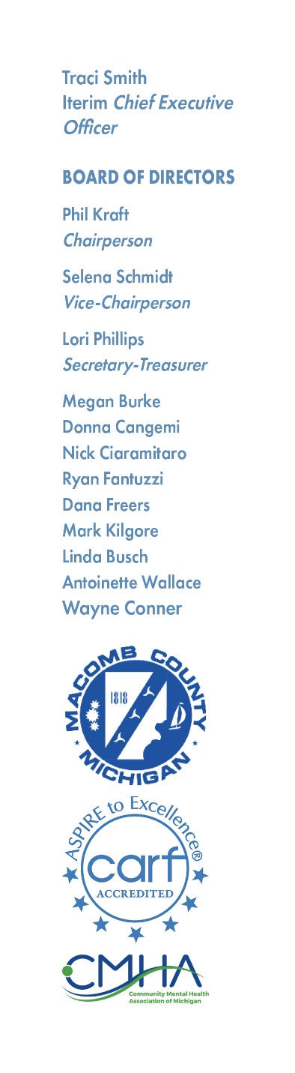

NOTICE OF MEETING

There will be a CMH SPECIAL FULL BOARD meeting on Wednesday, August 14, 2024, at 7:00 PM, or immediately following the CMH Board Program and Budget meeting at MCCMH – WEST 6555 15 Mile Road, Sterling Heights, MI

AGENDA

1. Call to Order
2. Adoption of the Agenda
3. Hearing of the Public
4. **ACTION ITEM**: Request to approve the recommendation of Traci

Smith to the Macomb County Community Mental Health CEO

position.

1. Hearing of the Public
2. Adjournment

**THE MCCMH MISSION STATEMENT**

Macomb County Community Mental Health, guided by the values, strengths, and informed choices of the PEOPLE WE SERVE, provides quality services which promote recovery, community participation, self-sufficiency, and independence.