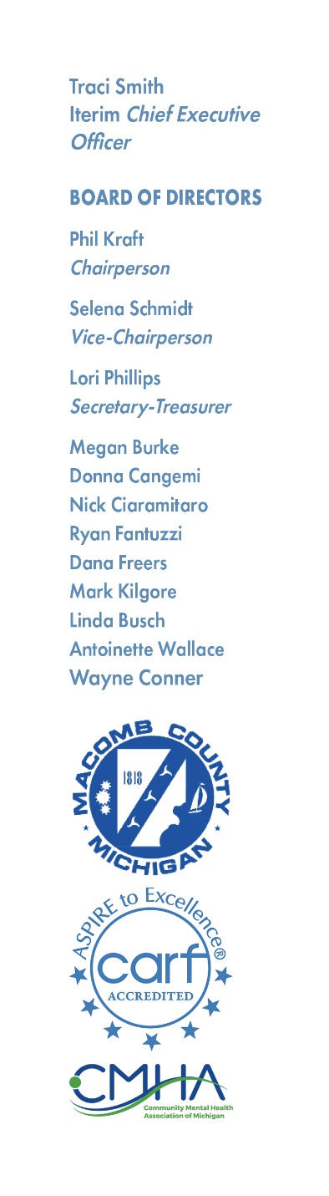

NOTICE OF MEETING

There will be a meeting of the PERSONNEL COMMITTEE of Macomb County Community Mental Health Services Board on Monday, July 1, 2024, at 11:00 AM, at MISD, 44001 Garfield Road, Clinton Township, MI 48038
Megan Burke
Megan Burke Chairperson

AGENDA

- Call to Order

- Reading of the Mission Statement

- Adoption of the Agenda

- Hearing of the Public

- Personnel Committee CEO Interviews – Round 2

- Hearing of the Public

- Adjournment

THE MCCMH MISSION STATEMENT
Macomb County Community Mental Health, guided by the values, strengths, and informed choices of the PEOPLE WE SERVE, provides quality services which promote recovery, community participation, self-sufficiency, and independence.

