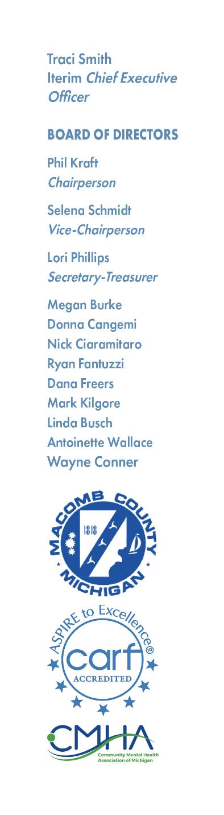

**CMH Board**

**Policy and Legislative Committee Meeting**

**Friday, June 21, 2024 @ 11am**

**AGENDA**

1. Call to Order

2. Reading of the Mission Statement

3. Adoption of the Agenda

4. Hearing of the Public

5. ISF Resolution

6. Waskul Settlement Declaration

7. CCBHC Advocacy Letters Discussion

8. Jail Exclusion Waiver Discussion

9. Other Business

10. Hearing of the Public

11. Adjourn

**THE MCCMH MISSION STATEMENT**

Macomb County Community Mental Health, guided by the values, strengths, and informed choices of the PEOPLE WE SERVE, provides quality services which promote recovery, community participation, self-sufficiency, and independence.