**MACOMB COUNTY**

**COMMUNITY MENTAL HEALTH SERVICES BOARD**

***RECIPIENT RIGHTS ADVISORY COMMITTEE***

**Thursday, December 12, 2024 – 8am**

**19800 Hall Road**

**Clinton Township, MI 48038**

**A G E N D A**

1. Call to Order
2. Reading of Mission Statement

3. Adoption of Agenda

4. Hearing of the Public

5. Review of Annual Report

6. Training on Policies (specific policies TBD)

7. Other Agenda Items

8. Hearing of the Public

9. Adjournment

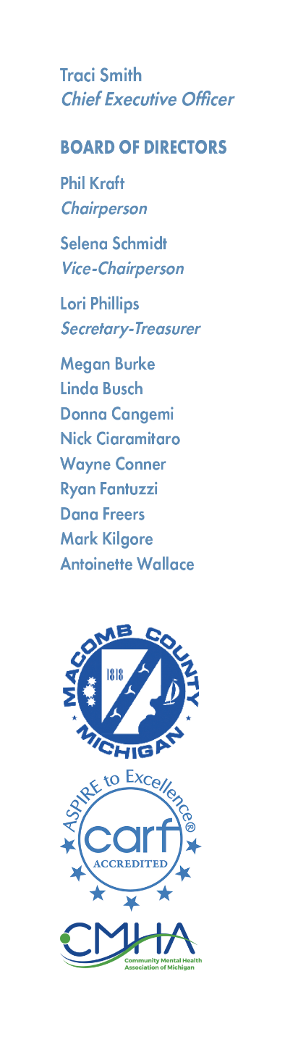

**MCCMH Mission Statement**

Macomb County Community Mental Health, guided by the values, strengths, and informed choices of the people we serve, provides quality services which promote recovery, community participation, self-sufficiency, and independence.